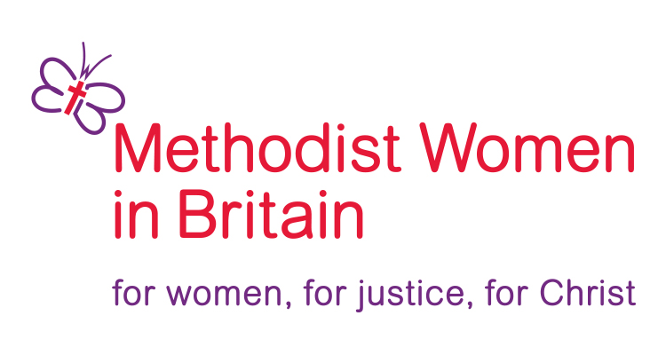
Empowerment Gifts
2023

Each year, MWiB donate £10,000 to share between projects supporting work with women overseas, selected by the MWiB Forum. Website - mwib.org.uk

MWiB will work closely with All We Can, WFM&UCW and Global Relationships Partnership Co-ordinators to identify suitable projects.

Suggestions for recipients of this year’s Empowerment Gifts are welcomed from Forum members. You are encouraged to read Methodist publications including The Connexion Magazine, Junior Mission For All – you can sign up to regular e-news from Global Relations and J.M.A. on the Methodist.org.uk website, ‘The Tree of Life’, Methodists for World Mission (MWM) magazine and Mission Partners’ newsletters and to select initiatives that are working to empower women through our partner churches.

The initiatives should be in accordance with the aims and objectives of MWiB and meet the following criteria:

Criteria
- The gift will help to advance the Christian faith - seeking “to know Christ and to make him known”.
- The gift will help to develop the capacity and skills of women members of the Methodist Church, enabling them to participate more fully in the life of the church, their community, and society.
- The gift will help to combat injustice and poverty in local communities and around the world.
(It may be helpful to consult the MWiB constitution for full information).
- Gifts will not be made to fund capital project [building work]
- Gifts will not be made to pay salary or ongoing staff costs.
6. The organisation must have a bank account and correct bank details must be given for a gift to be awarded. Personal bank accounts cannot be used.

Applications will be discussed by the MWIB executive and brought to the Autumn forum for approval. Please give details below.

Send your completed form to Sylvia White, MWIB, c/o Stamford Methodist Church, 11 Barn Hill, Stamford, Lincs, PE9 2AE or email empowermentgifts.mwib@gmail.com by 31st July 2023 for consideration.

1. Your name…………………………………….....………. Email address………….....…………………………………………

2. Your District ……………………………………………………………..

3. The initiative you would like us to support. Please provide a title and a brief description

Title ………………………………………………………………………….............…………………………………………………………

4. Please provide a budget plan showing how you would use any monies gifted to you [noting the criteria at 4 and 5 above].

5. Is this initiative supported by a Partner Church or Conference? Please specify

6. How did you learn about this initiative?

7. How would our gift specifically empower women through this initiative?

If you are awarded a gift, you will be contacted to provide your bank details

It is a requirement that a contact person in the UK, who can respond to any queries, is declared on each application. If the information required by the bank is not forthcoming by 31st March each year then the project will not benefit from the gift.

Methodist Women in Britain would very much appreciate feedback about the success of your project. You will therefore be contacted during the Summer following the gift to provide information about the progress of your work.

